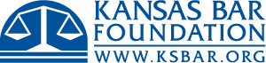
Executive Director

The Kansas Bar Association (KBA), based in Topeka, KS, is the voluntary, statewide association for legal professionals in Kansas with more than 7000 members, and the Kansas Bar Foundation (KBF), is a related organization promoting charitable and educational projects throughout the state. The KBA and the KBF’s respective boards are jointly seeking an Executive Director to help execute their vision for serving the legal community and advancing the interests of the legal profession. The job description and application process are available at: KBA Executive Director

